**Group 02: Database Schema**

Members:

Aryan Seth – 19UCC132

Dhruv Tripathi – 19UCC076

Sanjana Bansal – 19UCC135

Nitish Kumar Gupta – 19UCC131

**Table: 01 Admin Login**

This table stores admin login credentials.

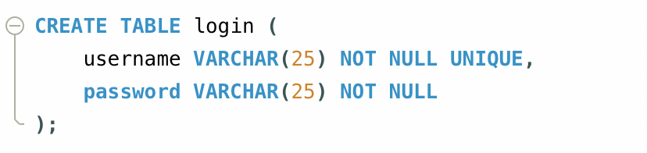

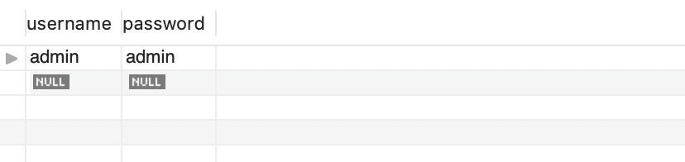

**Table: 02 Student Table**

This table tracks student details added/updated/deleted in the database by admin. Password is generated by the program and can later be changed by the user. Some of it’s columns are also used to track attendance and marks.

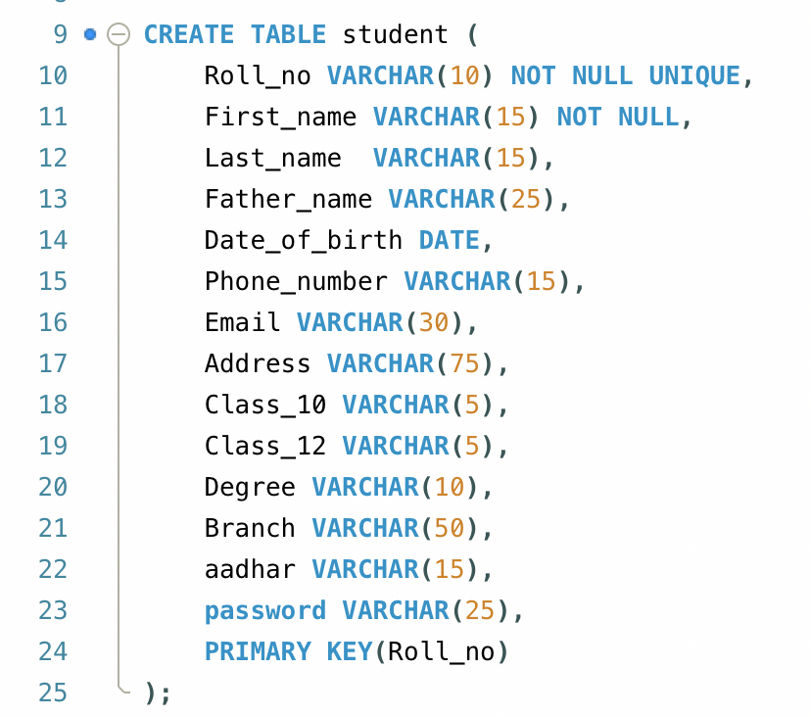



**Table: 03 Teachers Table**

This table tracks teacher details added/updated/deleted in the database by admin. Password is generated by the program and can later be changed by the user.



**Table: 04 Subject Table**

This table stores subjects added to the database by admin. This data is used at multiple places in the program.

**Table: 05 Student Attendance Table**

This table records attendance marked by a teacher. This table is also used when a student views their attendance.

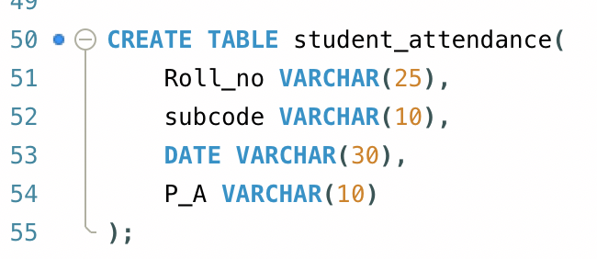

**Table: 06 Marks Table**

This table records marks uploaded by a teacher for their subject. This table is also used when a student views their result.

**Table: 07 Fees Table**

**This table is used to store fees paid by the students. It can only be accessed by the admin.**

